Parasitology End of sem Key notes 2023
- What are fleas
- Write notes on what fleas role in plague disease
- What are flies
- List all the families of flies that transmit diseases
- What phylum is Trematodes
- Write the Schistosomes diseases and the vectors for each
- What characteristics features make tapeworms identifiable
- Differentiate between filariform and rhabditiform larvae
- Differentiate between phasmid and aphasmid nematodes
- Differentiate between cutaneous and visceral larval migrans
- Describe the body wall of nematodes
- Whch of the nematodes affect humans
- Identify the insects from the diagram and state their parasitology importance
- 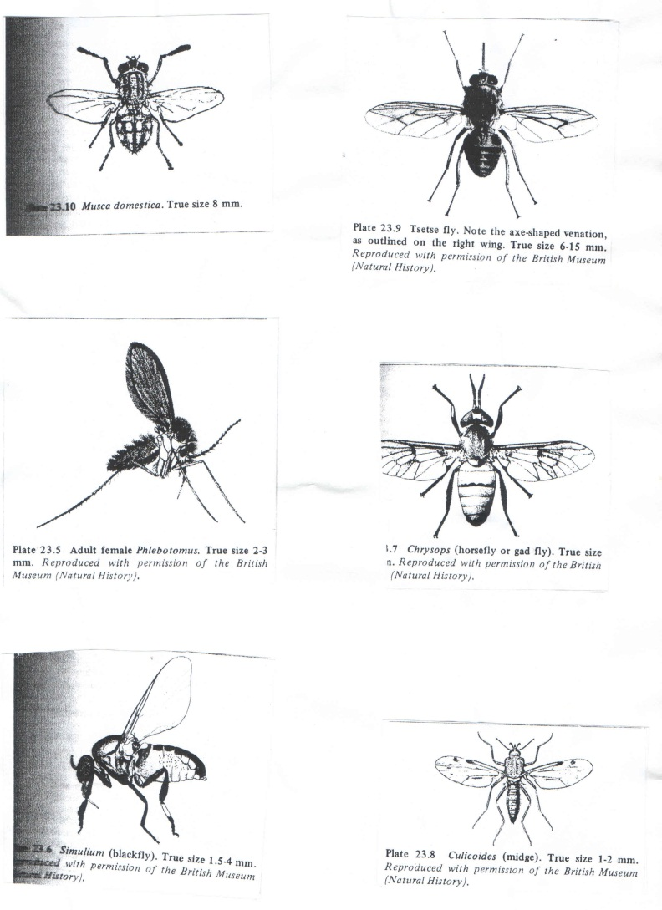
- What is myasis
- State and explain the two main types of myasis
- State all the families of insects that transmits myasi
- What name is given to the body cavity found in helminths
- What name is given to the canal in schistosomes that hold the female
- Diagrams of the stages of trypanosomes and asked to identify the stage

